Neo 4 J

Question 2

The ingredient nodes and cake nodes with ties to their recipe where created

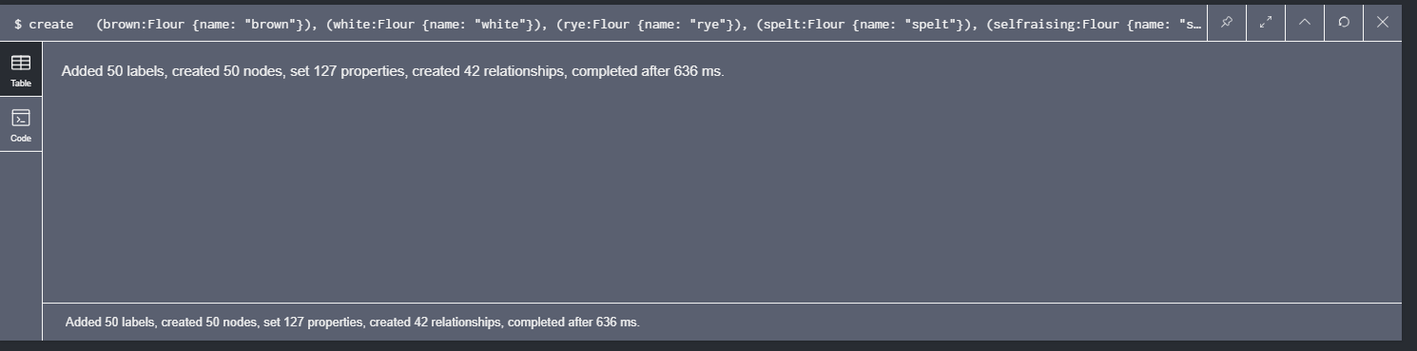

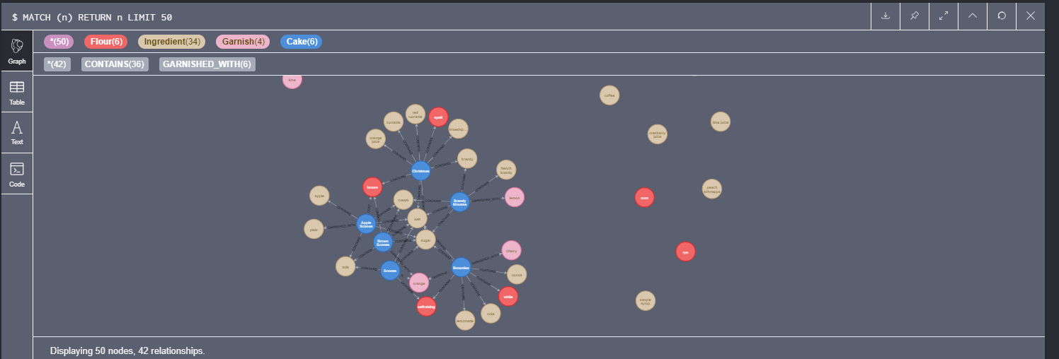

3 chefs were created

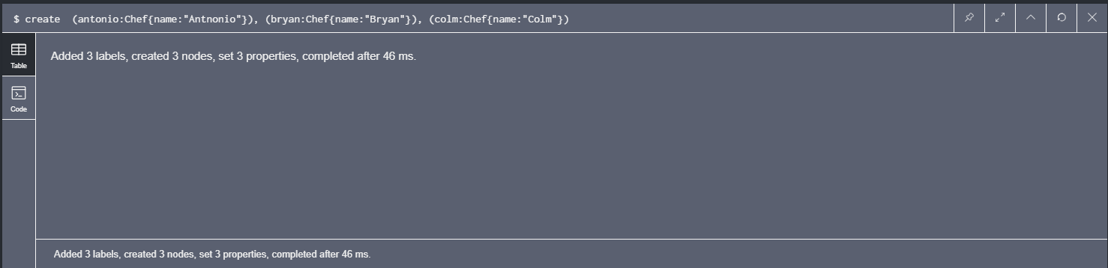

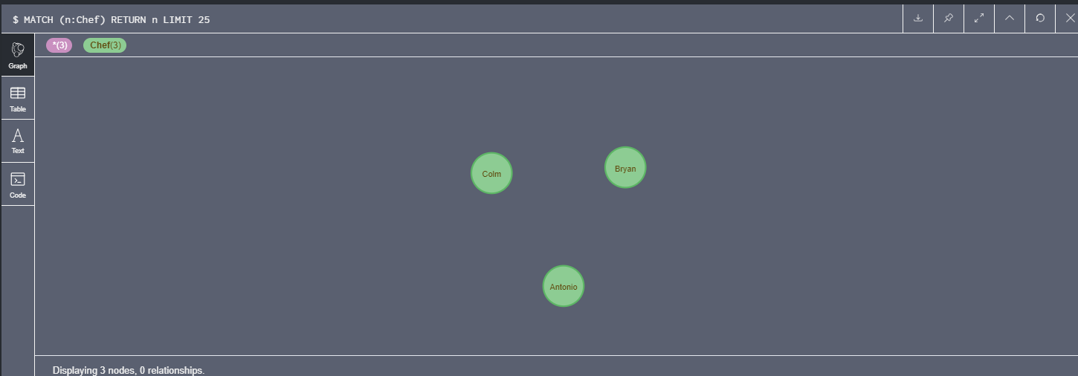

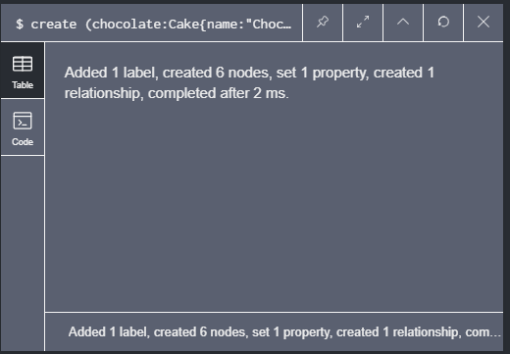 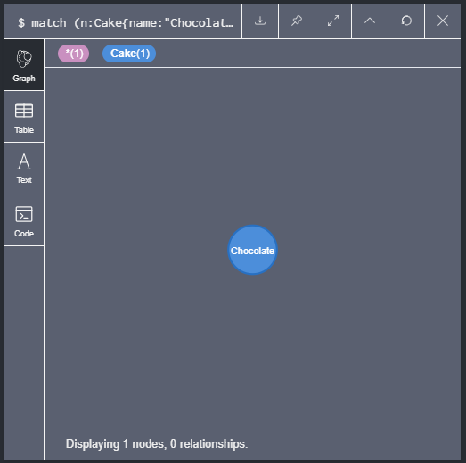

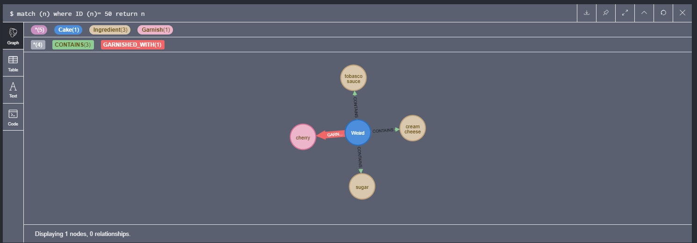

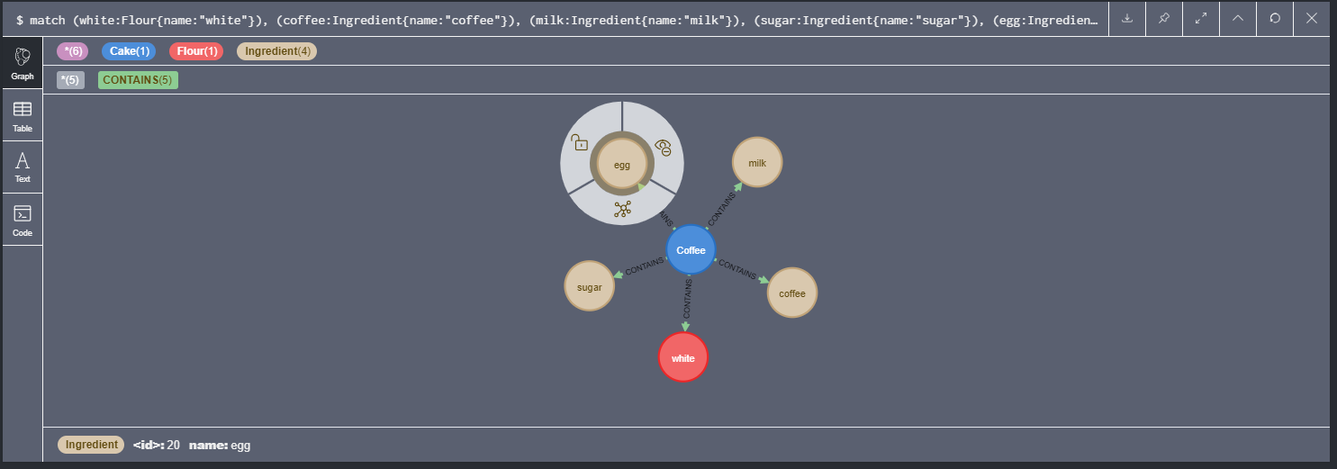

3 new cakes were created and relationships were given to the chefs

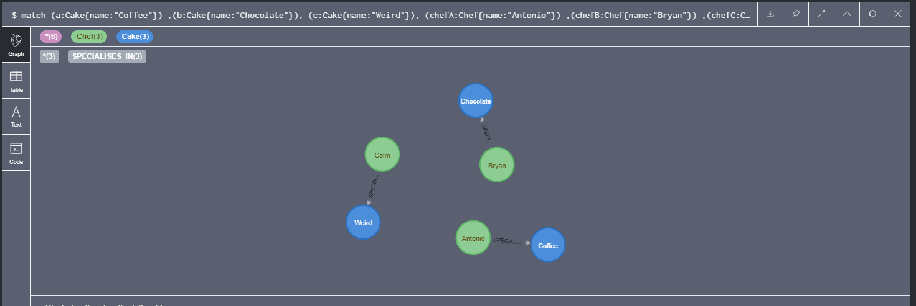

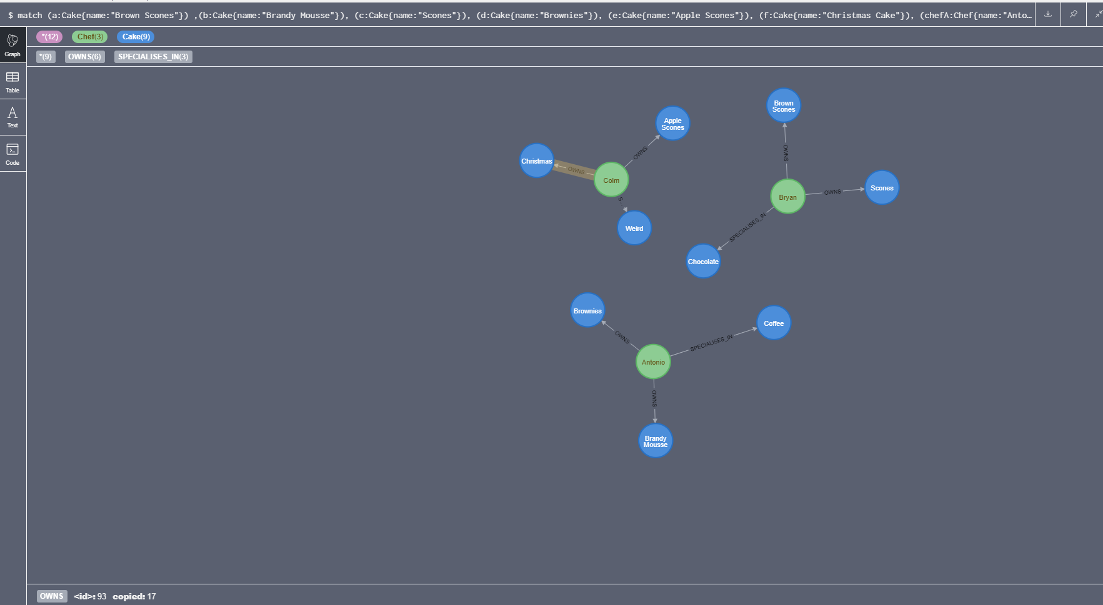

I had to go back over each of the chefs and their recipes to add in the popularity tag on the relations

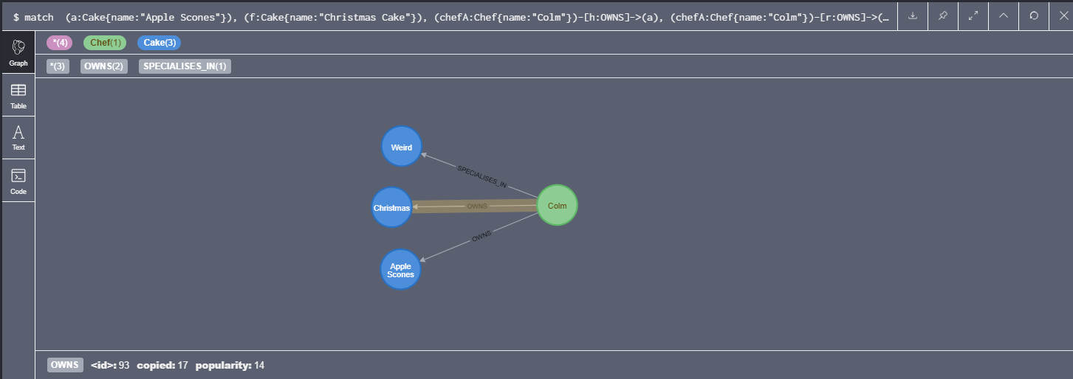

Query 2

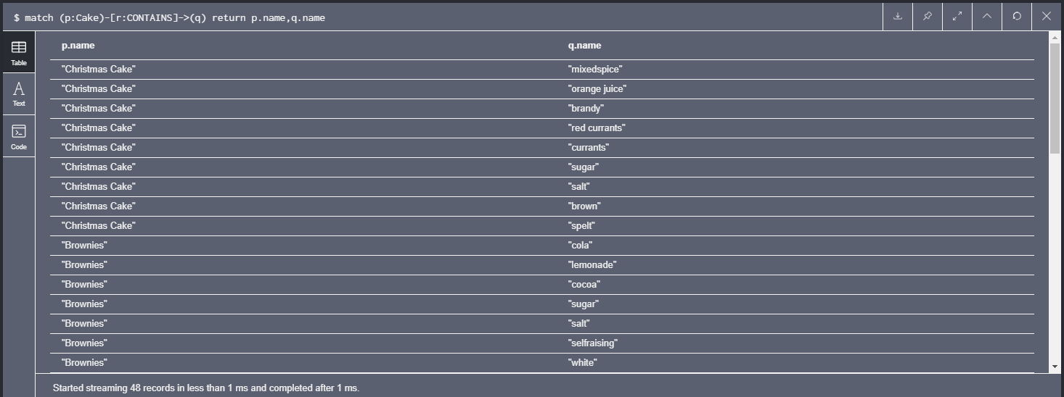

Query 3

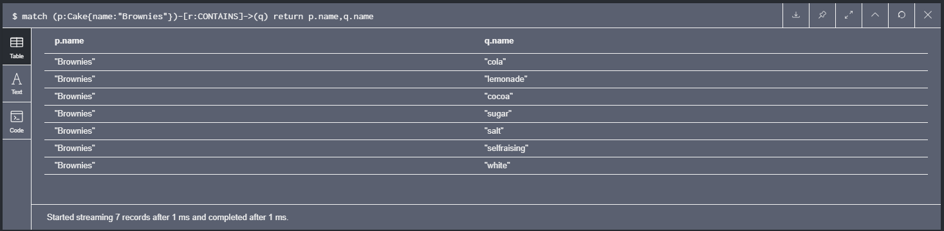

Query 4 ( the weird cake is the only cake that does not contain flour)

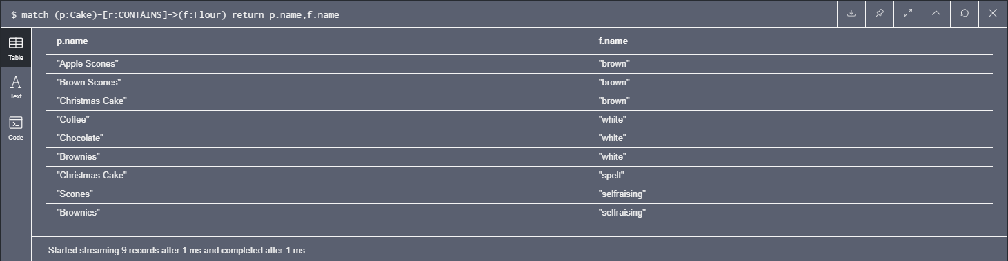

Query 5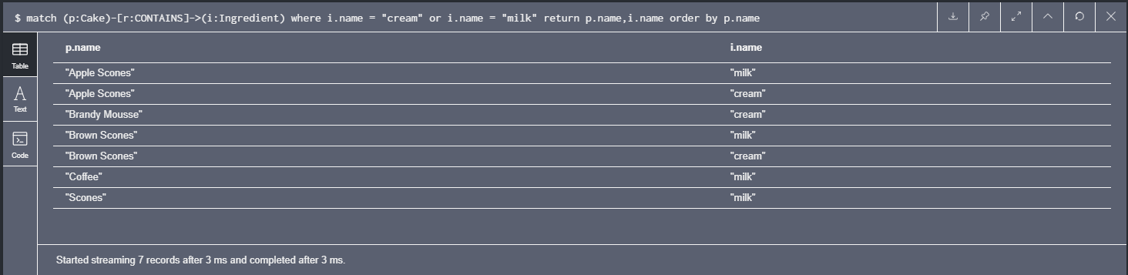

Query 6

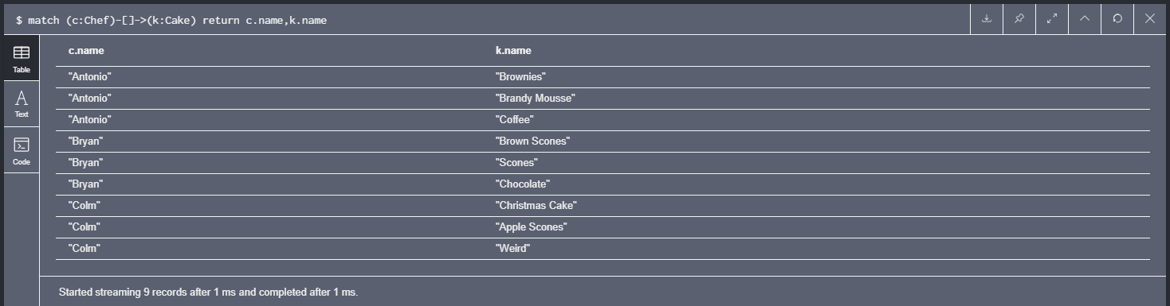

Query 7

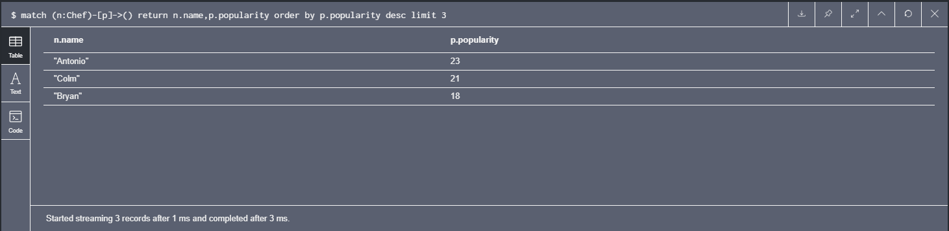

Query 8

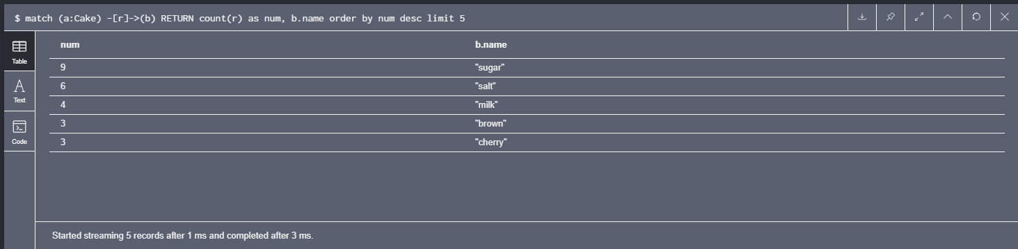

Query 9

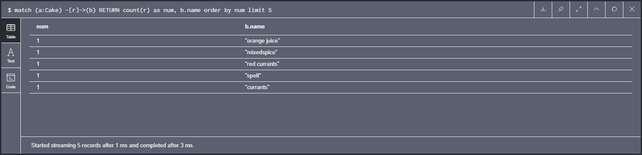

Query 10

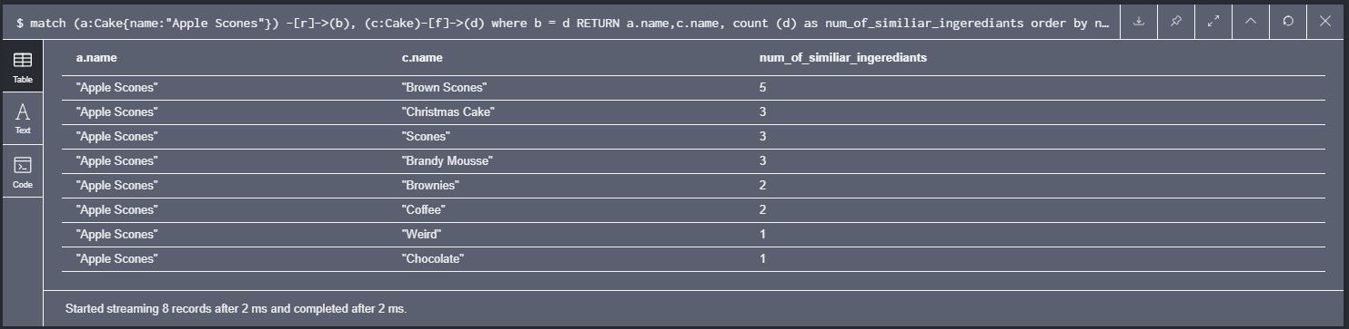

Part 3

Most popular cuisine

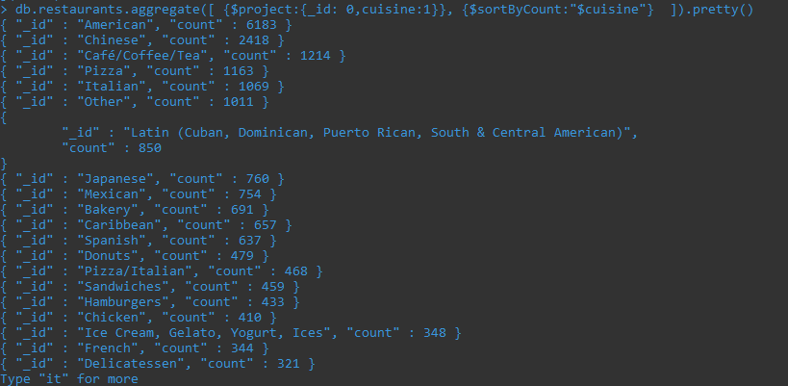

Cuisine per borough ordered by increasing on borough

